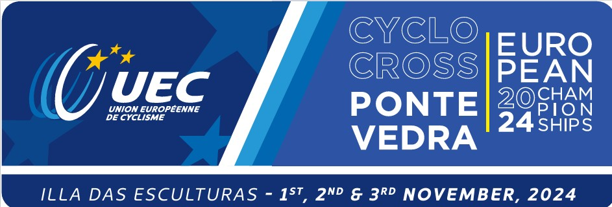

**CYCLO-CROSS TEAM RELAY**

**UEC EUROPEAN CHAMPIONSHIPS**

**Participation Intention Form**

**NATION:**

**YES:**

**NO:**

**DO NOT KNOW YET:**

**Please click inside the corresponding box, put an X and send the form by e-mail to:** [**v.petsas@uec.ch**](mailto:v.petsas@uec.ch), **no later than Friday 18 October 2024, 09h00 CET.**